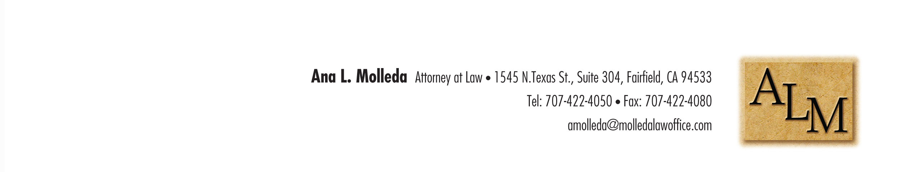

Hello Ana,

Here is the letterhead MS Word template with your logo/contact masthead.

Thank you,  
Steve Garson  
707-428-1743  
[www.garsondesign.com](http://www.garsondesign.com)