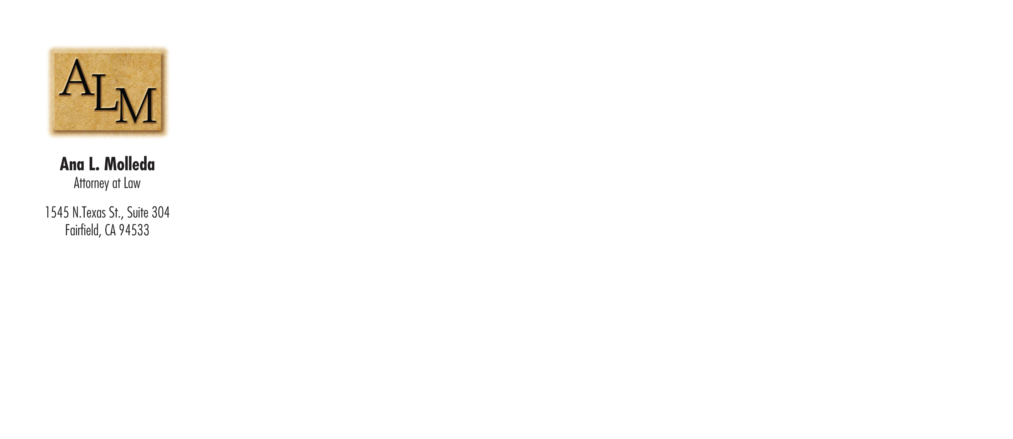

Steve Garson  
Garson Design Services  
239 Concord Ave.  
Fairfield, CA  
94533