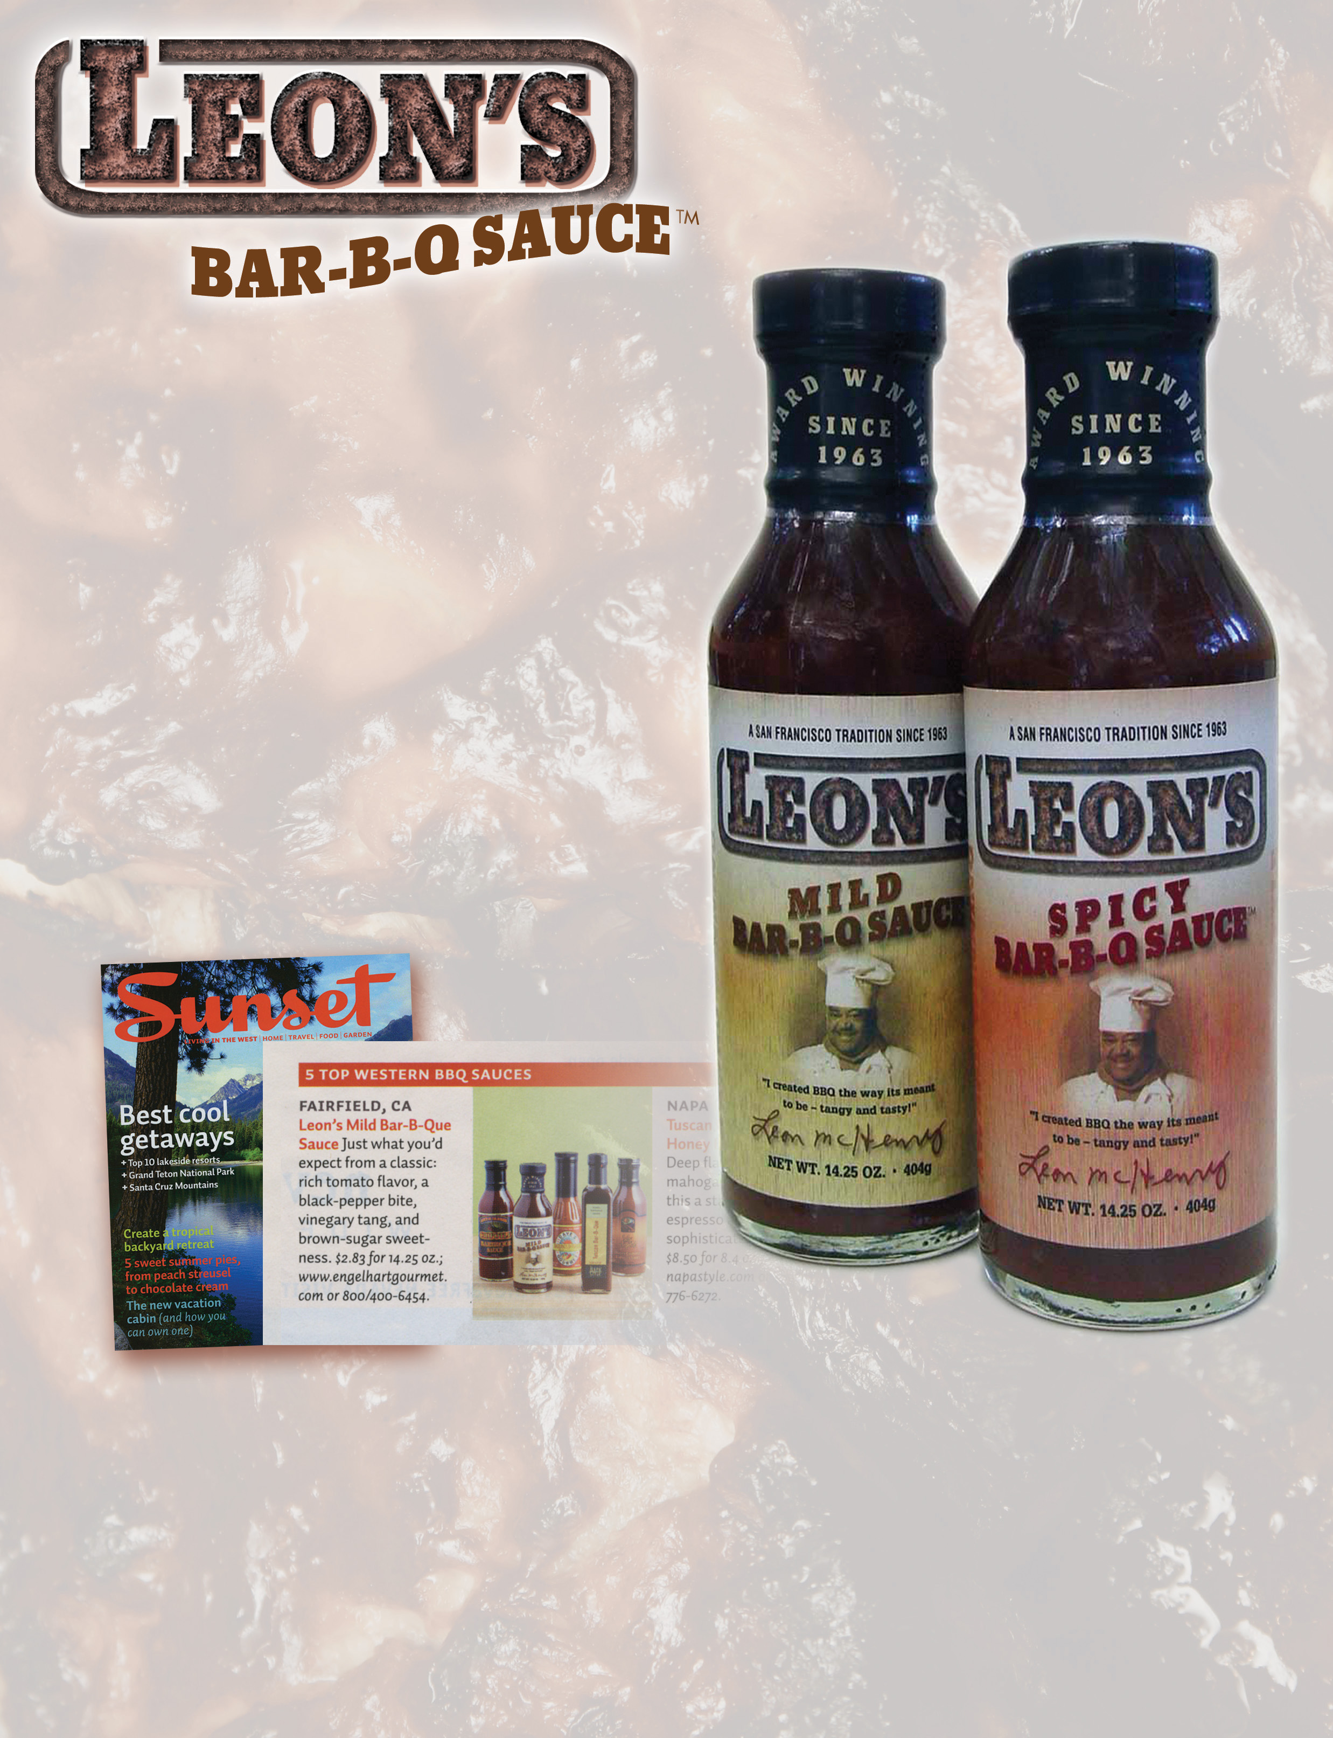  WHEN IT HAS TO BE THE VERY BEST!  WHY LEON’S BBQ SAUCE?  1. Awarded “Best in the West’ by Sunset Magazine - August 2007  Great Tasting = Repeat Sales!!  2. Leon’s BBQ Sauce is full bodied - not watered down! So you can serve less and save more!  3. Leon’s BBQ Sauce has a proven track record!  Available in most markets since 1988!  4. The Bar B’Q Sauce the experts ask for!  Used in many of the Bay Area’s finest Deli’s. | Spring BAR B’Q Sale for April and May!

Bottles Mild & Spicy 14.25 oz. ea. / 6 per case: $14.50/case SPECIAL: $12.50/case!

Gallons Mild 4 per case: $34.50/case SPECIAL: $30.00/case!

Also available: Leon’s All Beef Hot Links. Please call for a sample of our B’Q Sauce.

Engelhart Gourmet Foods • Leon’s Bar B’Q Sauce
2475 Courage Drive, Fairfield, CA 94533 • 415-388-9235/phone • 415-388-8600/fax tkeen89@msn.com • www.engelhartgourmet.com
4774F3033108

