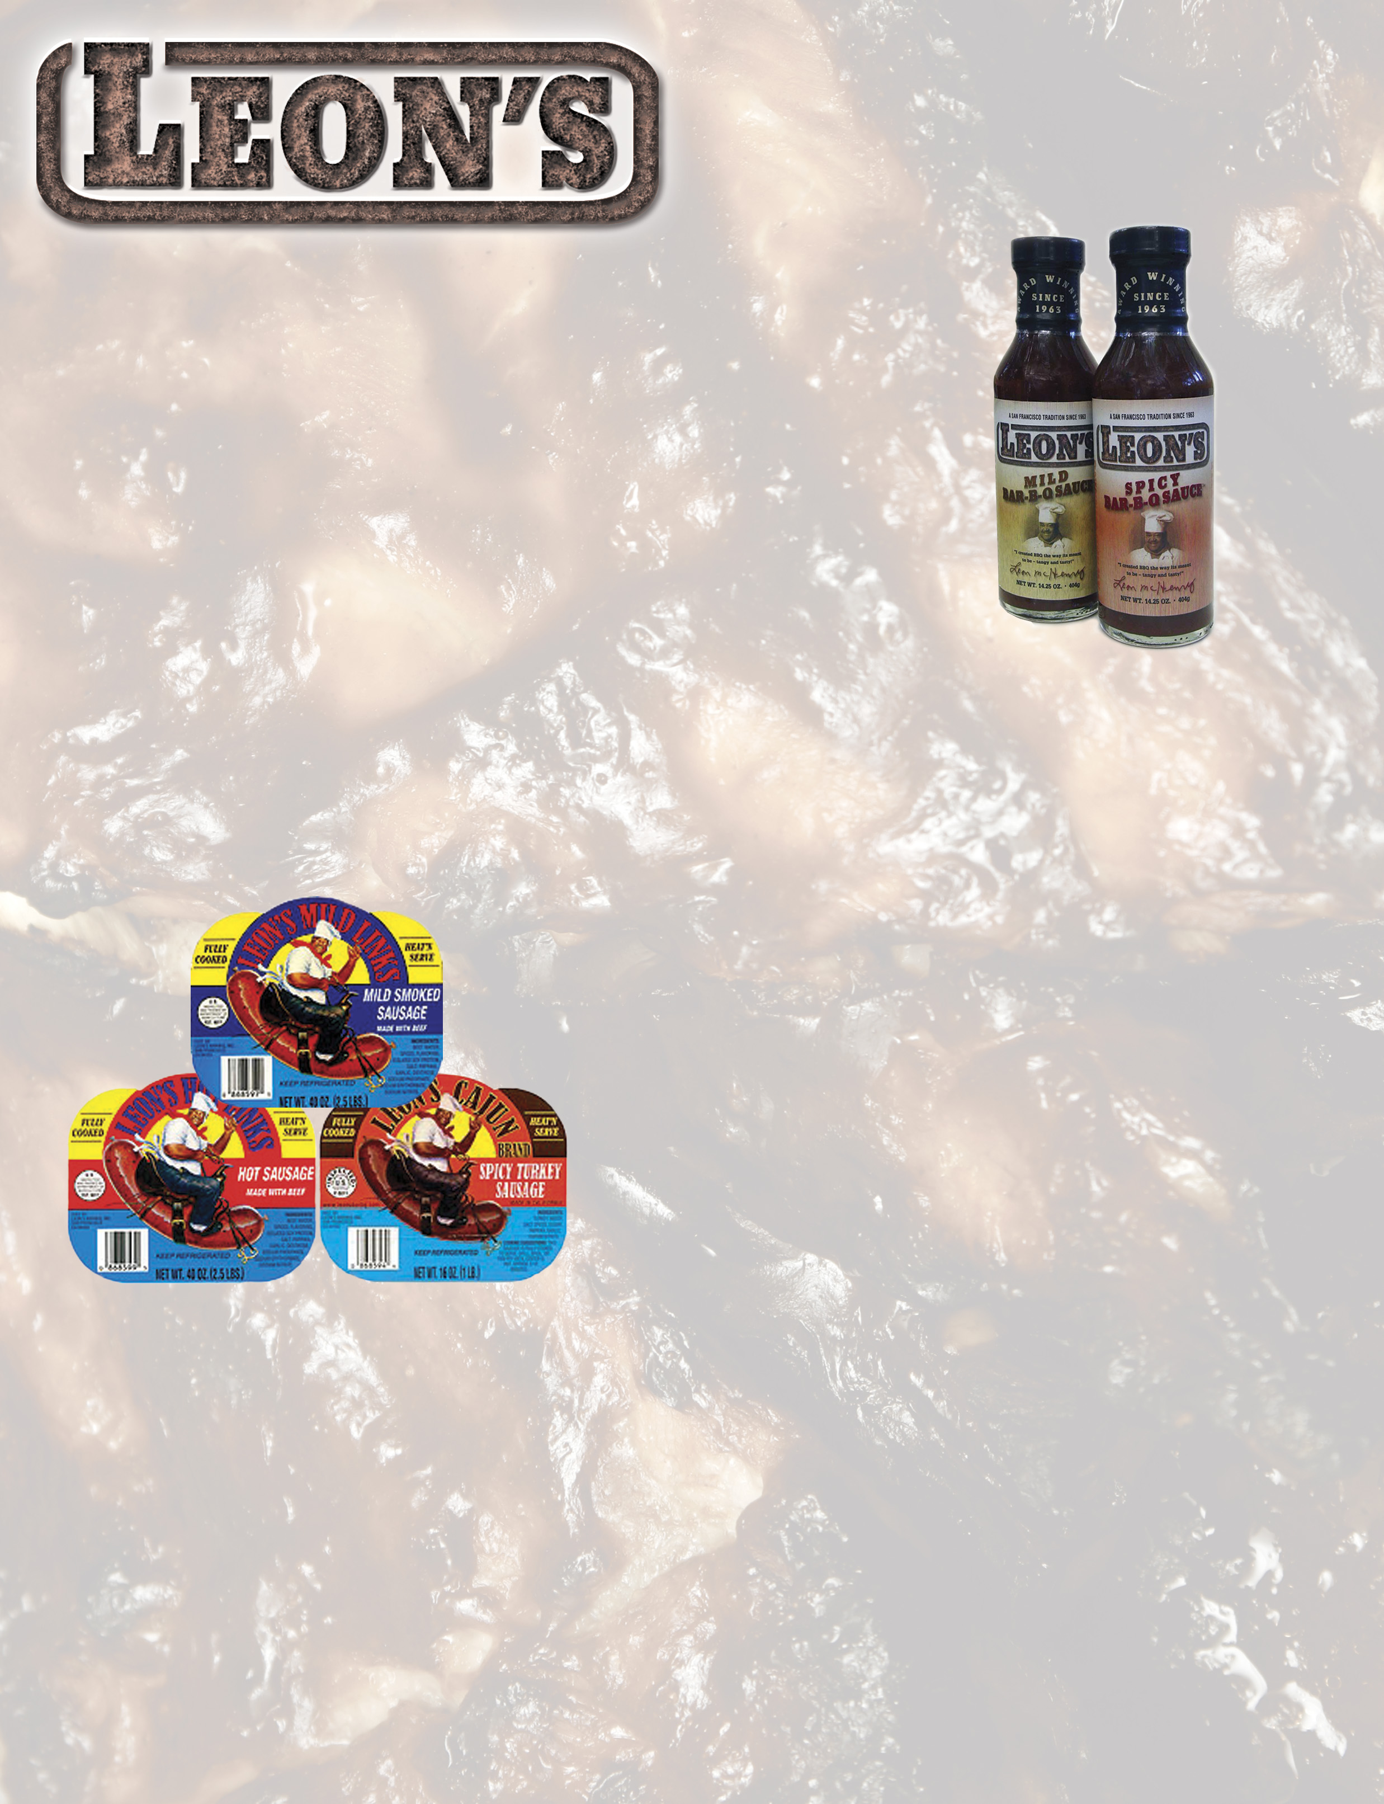

DISTRIBUTOR

PRICE LIST

LEON’S BBQ SAUCE

It’s Time To BARBEQUE!

Leon's "Award Winning" Bar-B-Q Sauce is a San Fransisco tradition since 1963… Contains no whey!

Pick-up address located at: Peppertree Warehouse
30527 San Antonio St., Hayward, CA. 94544-7101
(510) 487-1119/phone (510) 487-3164/fax

UPC DESCRIPTION PACK PALLET WEIGHT PRICE
0-86859-00020-0 Mild BBQ Sauce 6/14.25oz. 35 x 6 packs 5.3lbs. $12.79
0-86859-00021-7 Spicy BBQ Sauce 6/14.25oz. 35 x 6 packs 5.3lbs. $12.79
0-86859-00014-0 Mild Gallons 4/1Gals. 9 x 4 packs 40lbs. $30.00

LEON’S SAUSAGE

The Heat Is On!

Leon's Hot & Mild Links: All Beef, Pre-Cooked, Vacuum-Pak, Shelf Life 7 Weeks. Real Louisiana Hot Links. Great texture, great flavor! Leon's Cajun Sausages: All Turkey Thigh Meat, lean & just a little spicy!

Pick-up address located at: Home Sausage
1726 Mission Street, San Francisco, CA 94103
(415) 431-5580/phone

UPC DESCRIPTION PACK WEIGHT PRICE
0-868599-00005 Hot Link 6/2.5lbs. 15lbs. $2.20/lb $33.00/case
0-868597-00001 Mild Link 6/2.5lbs. 15lbs. $2.20/lb $33.00/case
0-868598-00008 Cajun 12/1lb. 12lbs. $2.30/lb $27.60/case

*Terms: Net 14 *Price Effective 03/12/07

Engelhart Gourmet Foods • Leon’s Bar-B-Q, Inc.
2475 Courage Drive, Fairfield, CA 94533
415-388-9235/phone • 415-388-8600/fax • tkeen89@msn.com • www.engelhartgourmet.com

4774F2b031507

