Start Up Your Grills!  It’s Time to BARBEQUE!!!  Summer is almost here, it’s time to bring home a little bit of the past from Leon’s Bar-B-Q of San Francisco. Leon’s Bar-B-Q restaurants are where large portions and a friendly smile were the standing order. Whether it was having ribs at Leon’s at the beach, or at the Fillmore, both were an experience to remember. Leon’s is now a landmark in everyone’s memory, but its great taste and flavor can still be found at your local market.  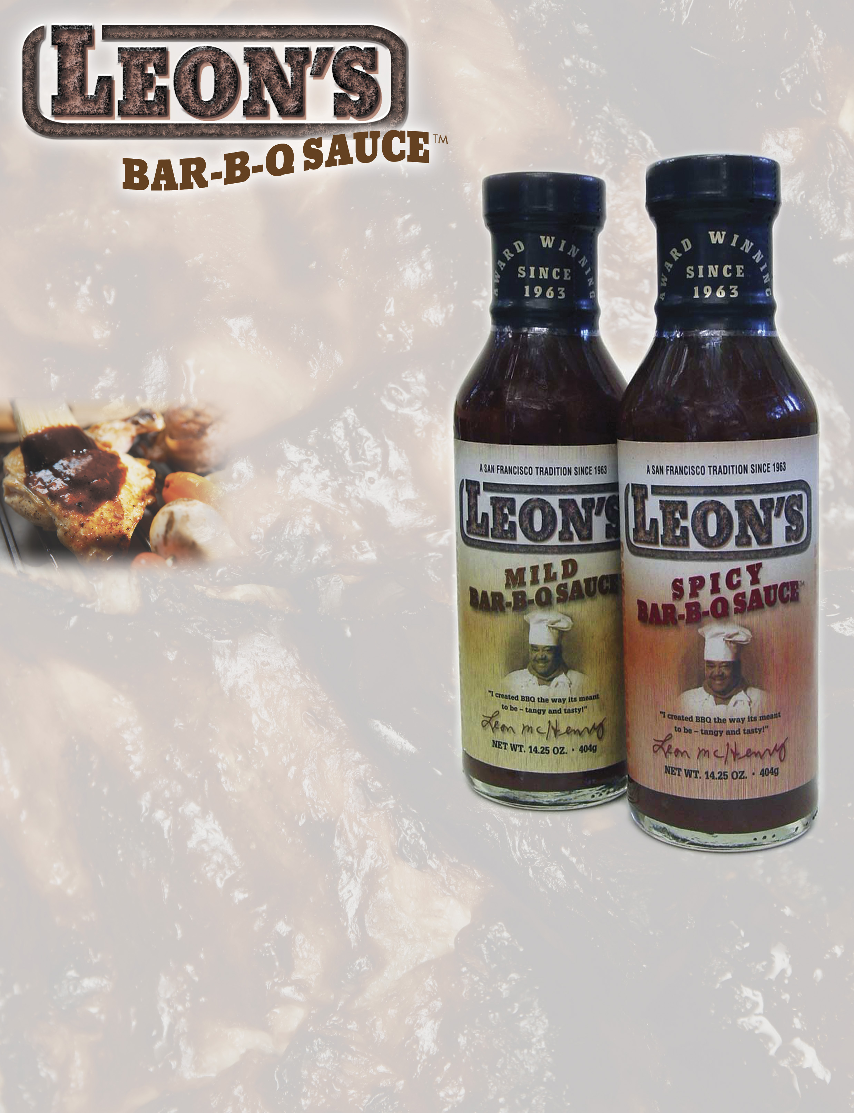  So pick up a bottle of Leon’s Award winning Bar-B-Q sauce this week, and bring a little magic to your barbeque. With its great taste, you’ll be part of the tradition that started in 1963.  Regular Price:  $12.79 per case ($2.13 per bottle)  Promotional Price:  $10.87 per case ($1.81 per bottle)  Take advantage of this special offer while supplies last. Place your order today before the peak grilling season starts! | Special Pricing  June 25^{th -} July 23rd

UPC Item Pack
0-86859-0020-0 Leon’s Mild Bar-B-Q Sauce 14.25 oz. each / 6 per case
0-86859-0021-7 Leon’s Spicy Bar-B-Q Sauce 14.25 oz. each / 6 per case

Engelhart Gourmet Foods • Leon’s Bar-B-Q Sauce
2475 Courage Drive, Fairfield, CA 94533
415-388-9235/phone • 415-388-8600/fax • tkeen89@msn.com • www.engelhartgourmet.com

4774F1c031407

