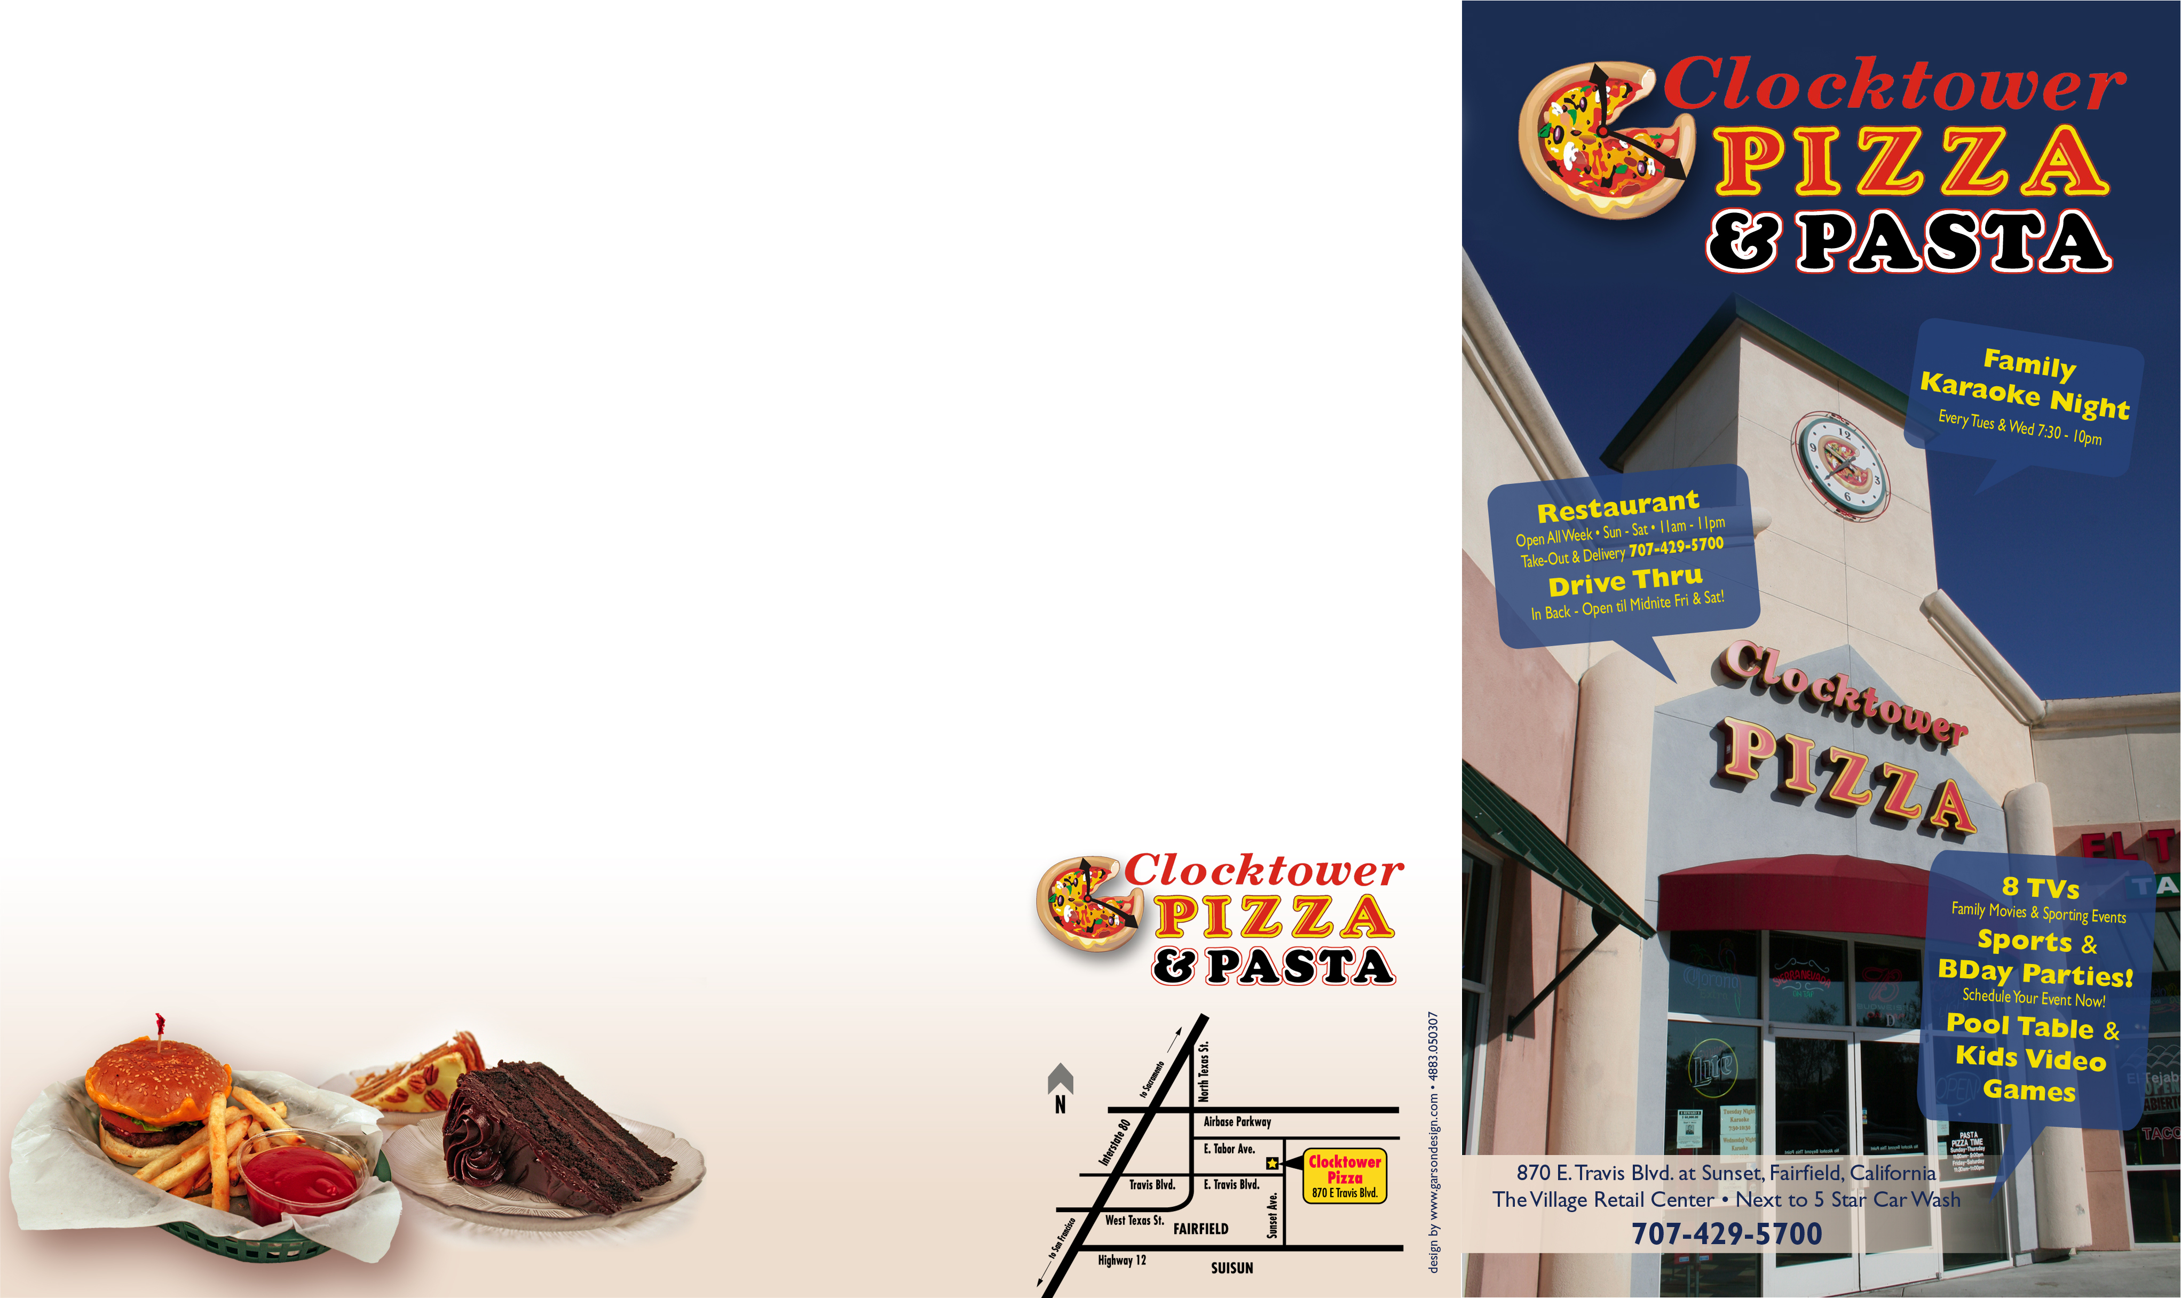
Served on baked foccacio bread with a bag of chips.

CLASSIC SANDWICHES Italian Meatball
Turkey, Roast Beef, Pastrami, Six large meatballs topped with our
or Clocktower Supreme meat sauce and melted mozzarella
with salami, peppperoni, ham, cheese. $5.49
bacon, black olives, lettuce,
tomato and mozzarella cheese. Cheese Steak or BBQ Steak
$5.49 Tender strips of steak topped with bell peppers, mushrooms, onions, and
melted cheese. $6.99

GRILLED CHICKEN
Bacon Ranch BBQ Honey Mustard
Chicken topped with bacon BBQ chicken topped Honey mustard
bits, mozzarella, lettuce, with melted mozzarella, smothered chicken, tomato and finished with lettuce, tomato, and lettuce, tomato, and
our homemade ranch. onions. mozzarella.
$6.49 $6.49 $6.49

All burgers are made with Pub style 100% beef steak hamburger
and are served with Clocktower’s signature oven fries.

Hamburger Cheeseburger Double Burger Double Cheeseburger
$5.29 $5.79 $7.79 $8.29

Western BBQ Burger Mushroom Burger Five Alarm Burger
Smothered with BBQ sauce Melted mozzarella, onions, Red and yellow
and topped with bacon, mushrooms, topped with onions, jalapenos,
cheddar cheese, and garlic ranch sauce. cheddar cheese,
onion rings. Chipotle sauce.
$5.99 $5.99 $5.99
Addional cheese to any burger for 50¢.

SIGNATURE CALZONES $5.99
Choose from our Signature Pizza Selections
Or our Signature Meatball Calzone
BUILD YOUR OWN CALZONE Choose two pizza toppings. $5.49
EACH ADDITIONAL TOPPING $0.50

ALL LUNCH SPECIALS END AT 4:00 PM.

ALL YOU CAN EAT! PERSONAL PIZZA AND SODA
A personal salad and as many Your choice personal pizza
personal pizzas you can eat. $6.99 $5.99

SANDWICH AND SODA PERSONAL PIZZA, SALAD
Choose from our Clocktower AND SODA
sandwiches $5.99 Your choice personal pizza and
side salad. $6.79

SANDWICH, SALAD & SODA LUNCH PASTA & SODA
Choose from our Clocktower Your choice of any pasta and
sandwiches and side salad. $6.79 sauce combination $7.99
.
1 Scoop Ice Cream $1.79 Root Beer Float $3.29
2 Scoops Ice Cream $2.79 Cake Slice $3.49
Ice Cream Sundae $3.49 Cake w/1 Scoop Ice Cream $5.49
Ice Cream Split $4.99 Churro $1.79
Milkshake $3.79 Cookie $0.99

Please ask for a list of available ice cream, cake, or cookies.

FOUNTAIN DRINK Free Refills $1.69 2 Liter and 20 oz. sodas
PITCHER OF FOUNTAIN DRINK $5.99 are available for delivery
JR. SIZE DRINKS Free Refills $1.29 ICED TEA $1.69
BREWED ROOT BEER $2.29 COFFEE $0.99
PITCHER OF ROOT BEER $6.99 GLASS OF MILK $1.69

DOMESTIC BEER PREM. BEER HOUSE WINESalmon Creek
BOTTLE $2.79 BOTTLE $3.49 GLASS $3.99
DRAFT $2.79 DRAFT $3.49 BOTTLE $12.95
PITCHER $7.39 PITCHER $8.25 WINE COOLER $2.79

Please ask for a list of our alcoholic drinks.
All items except alcoholic drinks are deliverable.

All prices are subject to change

Restaurant
Open All Week
Sun – Sat 11am – 11pm
Dine-In, Take-Out & Delivery

Delivery charges apply, $10 min. order. We accept most credit cards. No checks.

Drive Thru
In Back – Open til Midnite
Fri & Sat!

870 E. Travis Blvd. At Sunset
The Village Retail Center
Next to 5 Star Car Wash
Fairfield, California
707-429-5700

