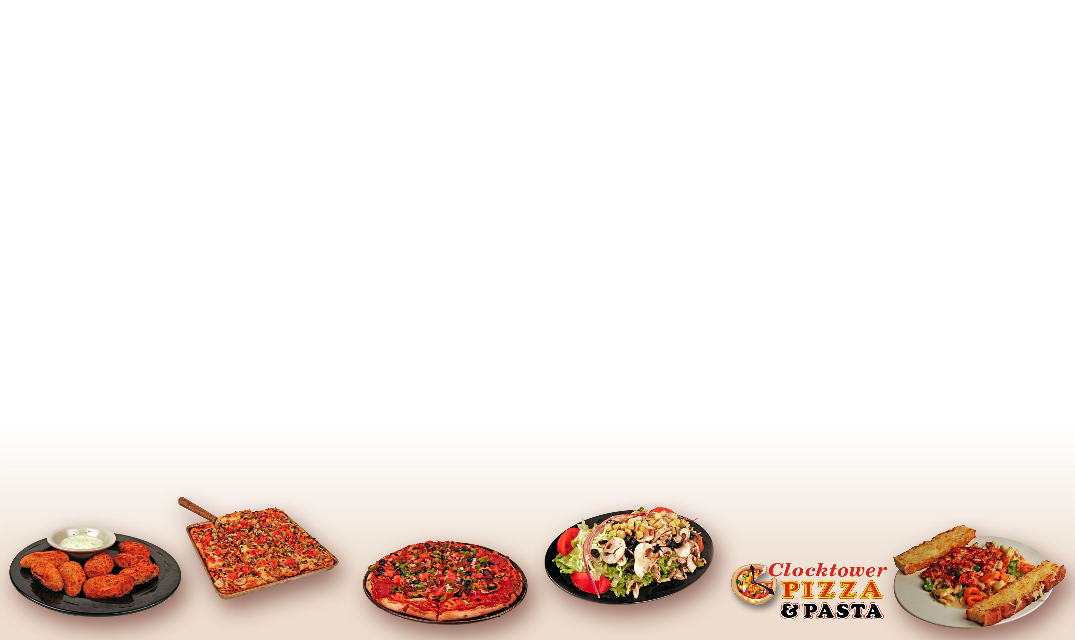

Cheesy Twists Cheesy Bread
6 hot, twisted breadsticks stuffed with Creamy garlic cream sauce layered
bacon and cheese topped with a creamy with a three cheese blend. $3.99
garlic sauce. $3.99
Basket of Onion Rings
Basket of Fries Crunchy oven baked onion rings.
Golden oven baked fries. Small:$4.99 Large:$6.99
Small:$ 3.99 Large:$5.99
Mozzarella Sticks
Nachos 9 breaded mozzarella sticks served
Crisp tortilla chips topped with with marinara or ranch dressing. $5.99
melted cheese. Toppings: Add your choice of chili,
spiced beef, lettuce, tomatoes, olives or sour cream Potato Skins
for $1.00 each. Small:$1.75 Large:$3.75 Stuffed with bacon, cheese, green
onions and sour cream.
Jalapeño Poppers 3 for:$3.99 5 for:$4.99 8 for:$7.99
Large breaded jalapenos stuffed with your
choice of cream or cheddar cheese. BBQ Pork Riblets
3 for:$3.99 5 for:$5.99 8 for:$7.99 Finger licking, slow cooked riblets
simmered in a tangy hickory BBQ
Chicken Tenders dressing. 1/2 lb.:$4.99 1 lb.:$7.99
Baked white chicken tenders served with
BBQ sauce, honey mustard, or ranch Wing Platter
5 pieces:$4.99 8 pieces:$7.99 A medley of our 4 different flavors of
wings (no substitutions)
Wings 16 pieces:$9.99
Tender, chicken wings served with your
choice of bleu cheese or ranch dressing. Baby Back Ribs
Choice of wings: Hot Buffalo, Honey BBQ, Italian Smoked baby back ribs smothered
Spice, Tequila Lime, Boneless in BBQ sauce
6 for:$3.99 12 for:$6.99 24 for:$12.99 1/2 rack: $10.99 Full rack: $18.99

Sampler Super Sampler
3 hot wings, 4 mozzarella sticks, 6 hot wings, 8 mozzarella sticks,
BBQ riblits, and cheesy bread $9.99 BBQ riblits, and cheesy bread $18.99

ALL KID’S MEALS INCLUDE JR. SODA AND JR. ICE CREAM $4.99
(No Jr. Ice Cream on Delivery)

PERSONAL PIZZA CHICKEN TENDERS MINI CORN DOGS
Choose one topping! 3 baked tenders with fries 4 mini corndogs with fries

RIBLET BASKET SPAGHETTI
3 BBQ Riblets with fries Spaghetti with meat sauce

New York Style: Thin Round Crust

Sicilian Style: Thick Square Crust

MED. LARGE GRAND
PERSONAL MED. SICILIAN LARGE SICILIAN FATHER
$5.99 $15.99 $16.99 $19.99 $20.99 $26.99

OMEGA ROLLEX
Garlic Cream Sauce, Chicken, Mushrooms, Garlic Cream Sauce, Grilled Chicken,
Red and Green Onions, Chopped Black Olives, Artichoke Hearts,
Tomatoes, Garlic and Lemon Pepper and Sun Dried Tomatoes

BIG BEN CLOCKTOWER SUPREME
Tomato Sauce, Salami. Pepperoni, Tomato Sauce, Pepperoni, Italian Italian Sausage, Black Olives, Bell Sausage, Linguica, Green Onions, and
Peppers, Red Onions, Fresh Mushrooms, Fresh Mushrooms
and Chopped Tomatoes
HOUR GLASS For Veggie Lovers!
THYME-X FOR MEAT LOVERS! Tomato Sauce, Red Onions, Bell
Tomato Sauce, Pepperoni, Salami, Ham, Peppers, Black Olives, Fresh
Bacon, Italian Sausage, and Spiced Beef Mushrooms, Artichoke Hearts, and
Chopped Tomatoes
BAJA TIEMPO
Tomato Sauce, Italian Sausage, Spiced SAYKO
Beef, Bacon, Jalapeño, Red Onions, Bell BBQ Sauce, BBQ Chicken, Red
Peppers, Chopped Tomatoes, Hot Onion, Fresh Mushrooms, and
Peppers, and Special Spices Black Olives

TACO TIME
Beans, Cheese, Bell Peppers, Black
Olives, Red Onion and Seasoned Beef
with fresh shredded Lettuce, Chopped
Tomatoes and Cheese

GRAND
PERSONAL MEDIUM LARGE FATHER
CHEESE $4.99 $11.99 $15.99 $20.99
1 TOPPING $4.99 $11.99 $15.99 $21.99
2 TOPPING $5.49 $12.99 $17.99 $22.99
EXTRA TOPPINGS $0.50 $1.00 $1.50 $2.00
SICILIAN (THICK) Add: ----- $1.00 $1.00 -----

TOPPINGS: Anchovies, Artichoke Hearts, Bacon, Bay Shrimp, Black Olives, Fresh Tomatoes, Chicken, Green Onions, Green Peppers, Ham, Italian Sausage, Jalapeño Peppers, Linguica, Fresh Mushrooms, Pepperoni, Red Onions, Salami, Sliced Pineapples, Spiced Beef, Sun-Dried Tomatoes

Served with garlic bread sticks!

Choose your Pasta: Fettuccini, Spaghetti, Penne, Tri Color Tortellini, Cheese Ravioli, Wild Mushroom Ravioli, Beef Ravioli, Manicotti, Cheese Stuffed Shells, and Egg Plant

Choose your Sauce: Alfredo, Garlic Ranch Alfredo, Marinara, Red Meat Sauce, Pesto

Add a side salad for $1.00

Geneva Lasagna L$8.99 D$9.99 Casio (Meat Lovers!) L$9.99 D$10.99
(Meat or Veggie) Our House Lasagna Red Meat Sauce, 2 Italian Meatballs,
covered with Marinara sauce. Sausage, Spiced Beef and Linguica

Quartz L$9.99 D$10.99 Fossil L$9.99 D$10.99
Red Meat Sauce, Sausage, Linguica, Pesto sauce, Mushrooms, Chopped
and Fresh Mushrooms Tomatoes, and Artichoke Hearts

Time Stopper L$9.99 D$10.99 Indiglo L$9.99 D$10.99
Garlic Ranch Alfredo Sauce, Chicken, Alfredo sauce, Chicken, Chopped
Sun Dried Tomatoes and Olives Tomatoes, Red Onions, Mushrooms,
Garlic, and Lemon Pepper

Add a side salad for $1.00

LUNCH DINNER
Pasta and Sauce (choose from above) $6.99 $7.99
1 Item $7.99 $8.99
2 Items $8.99 $9.99
Each additional item $1.00 $1.00

Items: Chicken, Shrimp, Sausage, Linguica, Italian Meatballs, Spiced Beef, Fresh Mushrooms, Fresh Tomatoes, Garlic, Green Onions, Red Onions, Bell Peppers, Artichoke Hearts, and Sun Dried Tomatoes
Add Lemon Pepper or Crushed Red Pepper to twist things up.

Caesar Crisp Romaine lettuce, cheese, and croutons, tossed in
Caesar dressing
Garden Mixed greens, red onion, tomatoes, cheese,
pepperoncinis, & croutons
Dressings Ranch, Creamy Caesar, 1000 Island, Italian, Blue Cheese,
Raspberry Vinaigrette, Honey Mustard

Personal Salad $3.99 Soup of the Day
With chicken $4.99 Cup $1.99
Each Additional topping $0.50 Bowl $3.49
Family (serves 3-4) $7.49 Soup and Salad
With chicken $9.49 Personal salad and Cup of soup
Each Additional topping $1.00 $4.99

