November 26, 2008
for immediate release

Contact: Emily Low- 422-0103 emily@fairfielddowntown.com / emlow@ci.fairfield.ca.us
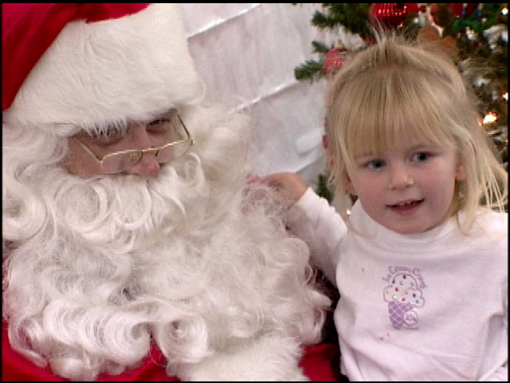
Who: Fairfield Downtown Association
What: Holiday Night of Lights
Where: Texas Street- Great Jones St to Jefferson St
Why: Kick off the Holiday Season downtown
When: Friday, December 5, 2008- 7:00 pm to 9:00 pm

The Fairfield Downtown Association will host its annual Holiday party and the arrival of Santa Claus on Friday, December 5, 2008, from 7:00 p.m. until 9:00 p.m. Festivities will take place in a variety of locations on Texas Street downtown, between County Center Plaza and Great Jones Street.

Santa Claus will arrive on a Fairfield Fire Truck, and light the Christmas tree with help from the Fairfield Downtown Association Board of Directors and the Fairfield City Council. Santa and Mrs. Claus will climb back aboard the fire engine to lead the children to Santa’s House at Art Explosion (821 Texas Street), where he will take gift requests until 9:00 p.m. Photos with Santa will be available for $3 each or a donation of non-perishable food items to be donated to the Food Bank of Solano and Contra Costa.

Buzzard’s Roost Ranch will offer carriage rides for $3 or a donation of non-perishable food items to be donated to the local Food Bank of Solano and Contra Costa. The carriage stop will be located at the south side of Texas Street/ Madison Street, in front of Fairfield Center for Creative Arts.

A Holiday Market Place has been added to the Holiday Night of Lights line-up this year. Local artisans will offer their hand-made items for sale in a special area in the courtyard of Fairfield Center for Creative Arts. Only hand-made items will be allowed in the Marketplace, providing quality gift items in a range of affordable prices. Several non-profit groups will participate in this area as fundraisers for their organizations.

Local Boy Scouts of America Troops 100 and 270 and Crew 100 will host a Christmas tree lot downtown. The lot will be at the corner of Texas Street and Taylor Street right across from Fairfield Center for Creative Arts. The lot will be open from November 28th. Hours will be Monday through Friday, 4 to 8pm and Saturday and Sunday, 10am to 5pm. There will be special extended hours for Holiday Night of Lights.

The Fairfield Scarlet Brigade Bag Pipes, Sheldon Elementary School band and choir, Rolling Hills Elementary School Choir, Laurel Creek Band, David Weir Elementary School Choir, and Danc-Sing Stars Studio are among the groups scheduled to perform during the event. We Dooz It costumed characters will be on hand for photo opportunities, and Alex Markoff will create balloon sculptures for guests.

Collectible lapel pins featuring the fanciful Holiday Night of Lights logo are available for $1. Children’s sweatshirts are available at $5. All the logo merchandise is available now by calling 422-0103 or at the FDA office- 1000 Texas Street across Texas Street from Cornerstone Quilt Shoppe.

Bring the family to Downtown Fairfield and visit one of our fine restaurants for dinner or dessert and a hot beverage. Enjoy hot cocoa and treats served by stores while they showcase their holiday merchandise and décor. Downtown retailers invite guests to browse in their stores while the children visit with Santa, make holiday decorations or decorate cookies. Holiday open house specials will let shoppers of all ages get a jump on the gift- buying season.

Local non-profit groups are cheerfully invited to participate as volunteers for the event. This is a terrific way for your student to earn those Community Service hours.
Free parking is available at municipal parking lots on Missouri and Empire Streets as well as in the multi story Solano County Government Center parking garage on Delaware Street.

