October 30, 2007
for immediate release

Contact: Emily Low- 422-0103 emily@fairfielddowntown.com
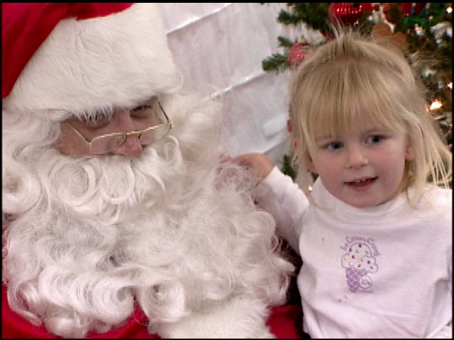
Who: Fairfield Downtown Association
What: Holiday Night of Lights
Where: Texas Street- Great Jones St to Jefferson St
Why: Kick off the Holiday Season downtown
When: Friday, November 30, 2007- 6:30 to 8:30pm

The Fairfield Downtown Association will host its annual Holiday party and the arrival of Santa Claus on Friday, November 30, 2007, from 6:15pm to 8:30pm. Festivities will take place in a variety of locations on Texas Street downtown, between County Center Plaza and Great Jones Street.

The 45- foot Christmas Tree will stand at the corner of Madison Street and Texas Street.

Santa Claus will arrive on a Fairfield Fire Truck, and light the Christmas tree with help from the Fairfield Downtown Association Board of Directors and the Fairfield City Council. Santa and his helper will climb back aboard the fire engine to lead the children to Santa’s House (821 Texas Street), where he will take gift requests until 8:30pm. Photos with Santa will be available for $2 each or a donation of non-perishable food items to be donated to the Food Bank of Solano and Contra Costa.

Buzzard’s Roost Ranch will offer carriage rides for $2 or a donation of non-perishable food items to be donated to the local Salvation Army food bank. The carriage stop will be located at the south side of Texas Street/ Madison Street, in front of Fairfield Center for Creative Arts.

The Fairfield Scarlet Brigade Bag Pipes, Dover Middle School Jazz Band, Laurel Creek Band, David Weir Choir, Anointed Children of God Chorus, Escape Community Church, Samoan Christian Fellowship, Company D Ballet and Danc-Sing Stars Studio are among the groups scheduled to perform during the event. We Dooz It costumed characters will be on hand for photo opportunities, and Alex Markoff will create balloon sculptures for guests.

Collectible lapel pins and shirts featuring the fanciful Holiday Night of Lights logo are available. Shirts are available in children’s sizes at $5 and adult sizes at $10. They are heavy weight shirts and generous in size. Lapel pins are $1. All the logo merchandise is available now by calling 422-0103 or at the FDA office- 1000 Texas Street across Texas Street from Cornerstone Quilt Shoppe.

Bring the family to Downtown Fairfield and visit one of our fine restaurants for dinner or dessert and a hot beverage. Enjoy hot cocoa and treats served by stores while they showcase their holiday merchandise and décor. Downtown retailers invite guests to browse in their stores while the children visit with Santa, make holiday decorations or decorate cookies. Holiday open house specials will let shoppers of all ages get a jump on the gift- buying season.

Local non-profit groups are cheerfully invited to participate as volunteers for the event. This is a terrific way for your student to earn those Community Service hours.
Free parking is available at municipal parking lots on Missouri and Empire Streets as well as in the multi story Solano County Government Center parking garage on Delaware Street.

The event will affect traffic in downtown. Madison Street mid-block between Empire Street and Missouri Street mid-block will be closed on November 20th for the arrival and set-up of the Christmas tree. On Friday, November 30th, Madison Street will be closed again for the set up of the stage. Texas Street between Taylor Street and Jackson Street will be closed at 4:00pm, with signs posted to direct drivers around the closure to the restaurants and shops. Texas Street between Great Jones Street and Jefferson Street will be closed from 5:00 to 9:30pm. All of the restaurants and many of the shops will remain open for the event.

