Fairfield Downtown Association

Certified Farmers Market- May 3rd through October 4th. The market is located at County Center Plaza. Pacific Coast Farmers Market Association manages the market featuring an array of farm fresh produce, gourmet foods, oysters, flowers and crafts. Live music and free children’s arts and craft projects are also featured.
- Attendance averages approximately 700 shoppers weekly, peaking to 1200 weekly during July.
- Advertising includes thirty-second radio spots, thirty-second commercials on Fairfield’s city-owned cable television station and print advertising in local newspapers and periodicals.

Independence Day Parade- July 4th. The parade marches from the corner of Webster and Kentucky Streets around Taylor Street and down Texas Street. In addition to the parade, a local non-profit hosts a fundraiser barbeque on the Courthouse lawn, with a free concert from 11am to 2pm
- Attendance includes approximately 1,000 people participating in the parade, and 5,000 to 7,000 people lining the streets as spectators.
- Advertising includes thirty-second public affairs and news spots on radio, thirty-second commercials on Fairfield’s city-owned television station and print advertisements in local newspapers and periodicals.

Sixteenth Annual Tomato Festival and West Coast Barbeque Championship- August 18th. The festival features nearly a hundred varieties of locally grown heirloom tomatoes and an assortment of gourmet tomato products for tasting and sale. Over 200 crafters and artisans will be on hand, and there will be a variety of delicious foods to choose from.
- Attendance has increased steadily over the last five years, from 15,000 people in 2001 to approximately 45,000 people in 2006.
- Advertising includes thirty-second television commercials on both English and Spanish language stations, including Food Network, Nickelodeon, ESPN, Discovery Channel, ESPN2, MTV, Animal Planet and AMC. Additional marketing includes sixty-second commercials on radio and print ads in local newspapers and periodicals. LED marketing boards in Vallejo and Fairfield also carry the information about the event.

Seventh Annual Candy Festival- October 13th. Candy-related companies fill two pavilions for sampling and buying. Nearly 200 craft and commercial booths, international food favorites and live music are included.
- Attendance has increased annually, from 5,000 in 2001 to 40,000 people in 2006.
- Advertising includes thirty-second television commercials on both English and Spanish language stations, including Food Network, Nickelodeon, ESPN, Discovery Channel, ESPN2, MTV, Animal Planet and AMC. Additional marketing includes sixty-second commercials on radio and print ads in local newspapers and periodicals. LED marketing boards in Vallejo and Fairfield also carry the information about the event. In addition, 15,000 bilingual flyers are distributed through the Fairfield-Suisun Unified School District.

Holiday Night of Lights- November 30th. Santa Clause arrives, and merchants host the lighting of the Community Christmas tree. If sufficient funding can be obtained, a temporary ice rink will be erected on County Center Plaza for the holiday season.
- Attendance at this event averages 7,500 each year, but it is anticipated that an ice rink would bring additional guests attracted to a unique element.
- Advertising includes thirty-second radio commercials, thirty-second television commercials on Fairfield’s city-owned station, and print ads in local newspapers and periodicals. In addition, 15,000 bilingual flyers are distributed through the Fairfield-Suisun Unified School District. Regional advertising will be increased if an ice rink is obtained.
Fairfield Downtown Association

Certified Farmers Market | Independence Day  Celebration | 16th Annual Tomato Festival | 7th Annual Candy  Festival | Holiday Night of  Lights  Seasonal Ice Rink
$15,000 | $10,000 | $25,000 | $25,000 | $25,000
“Presented by” Acknowledgement | “Presented by” Acknowledgement | “Presented by” Acknowledgement | “Presented by” Acknowledgement | “Presented by” Acknowledgement
Logo banner at market site | Logo banner at Reviewing Stand | Logo banners at Texas Street entrances to the festival | Logo banners at Texas Street entrances to the festival | Logo banners at Texas Street entrances to the event and ice rink
 |  | Logo and name on all advertising materials | Logo banner at Candyland entrance
Logo and name on all advertising materials | Logo and name on all advertising materials | Live link from FDA website to yours | Logo and name on all advertising materials | Logo and name on all advertising materials
Free weekly booth at the market | Seating on the Reviewing Stand | 2 Free booths at the festival | 2 Free booths at the festival | 2 Free booths near the Christmas tree or ice rink
 | Company name on Grand Sweepstakes Award trophy | 12 T-shirts or other logo wear | 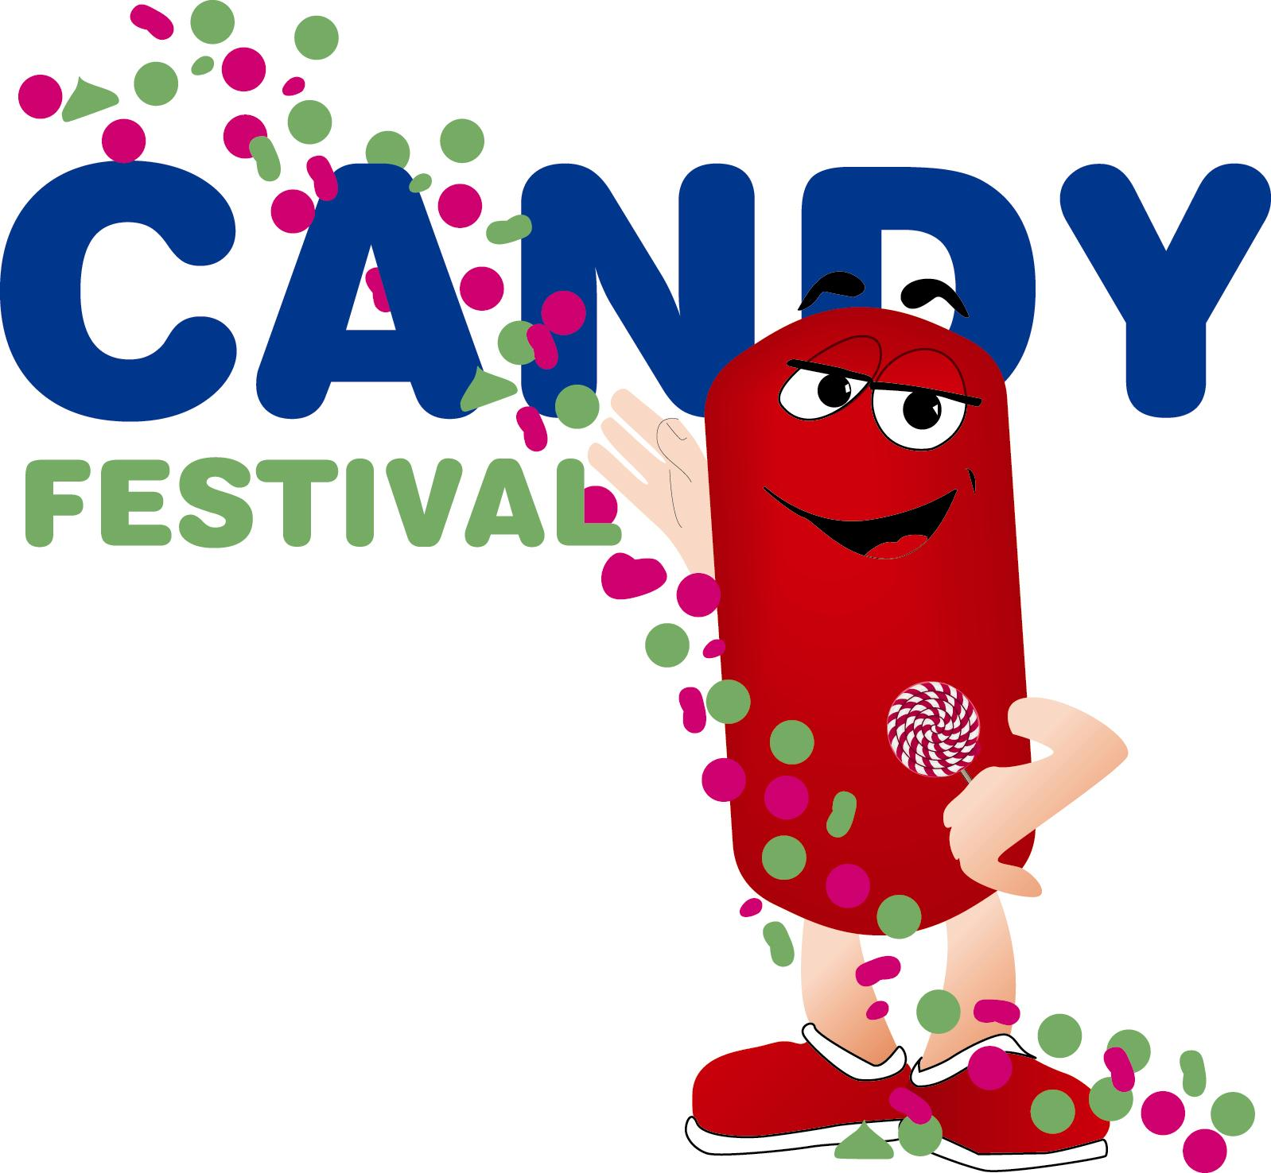
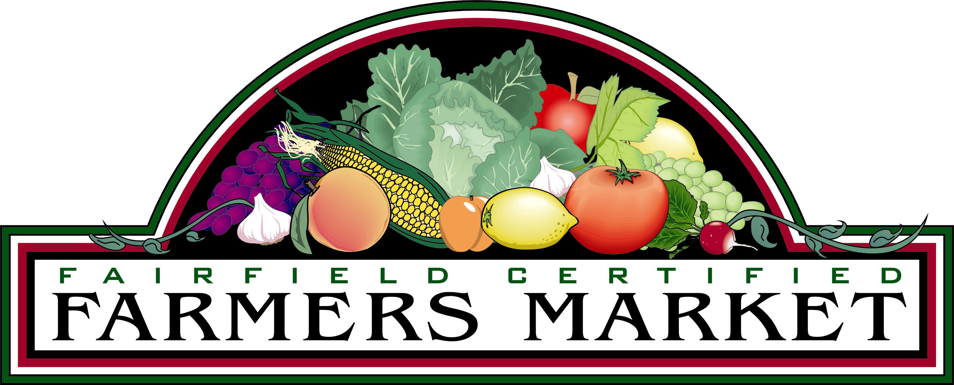 | Opportunity to present the Grand Sweepstakes Award trophy at the Fairfield City Council meeting | Introduction and acknowledgement at all entertainment venues throughout the festival | Opportunity to present  “Candy Factor” awards at the festival
12 T-shirts or other logo wear | Live link from FDA website to yours |  | Live link from FDA website to yours | Live link from FDA website to yours
Live link from FDA website to yours | 12 T-shirts or other logo wear |  | 12 T-shirts or other logo wear | 12 T-shirts or other logo wear
Introduction and acknowledgement each week | Introductions and acknowledgement throughout the parade, barbeque and concert | For specific sponsorship opportunities for the Barbeque Championship call Ben- 888-517-4150 | Introduction and acknowledgement at all entertainment venues throughout the festival | Introduction and acknowledgement at all entertainment venues throughout the event

Fairfield Downtown Association

Annual Sponsorship Application

Company Name________________________________Tax ID Number_______________________

Business Name_____________________________________________________________________

City__________________________________State___________________Zip__________________

Key Contact______________________________________Title_____________________________

Phone ( )_______________________________Fax ( )_________________________________

Email ___________________________________________________________________________

Additional Contact__________________________________Title___________________________

Phone ( )_________________________________ Fax ( )_________________________________

Email ___________________________________________________________________________

Company Website__________________________________________________________________

Specific Event(s)-
 | Sponsorship Level | Sponsorship Cost | Payment Due
A | Certified Farmers Market | $15,000 | 1-Apr
B | Independence Day Celebration | $10,000 | 1-May
C | Tomato Festival | $25,000 | 15-Jun
D | Candy Festival | $25,000 | 15-Aug
E | Holiday Night of Lights, Ice Rink | $25,000 | 30-Sep
 | Sponsor 2 or more events- take off 20%
 | Sponsor 3 or more events- take off 30%
Please circle as applicable:
- Certified Farmers Market-$ 15,000
- Independence Day Celebration- $10,000
- Tomato Festival- $25,000
- Candy Festival- $25,000
- Holiday Night of Lights, Ice Rink- $25,000

Total Investment Amount(s)- $________________
Applicable Discount $___________________________
Total Due to FDA $_____________________________
Terms:
10% Non-refundable deposit due on signing. Balance due 60 days prior to first day of event as noted on chart. If monies are not received by due date, sponsorship position is forfeited. FDA reserves the right to terminate the agreement.

Signature __________________________Printed Name__________________________Date_________

