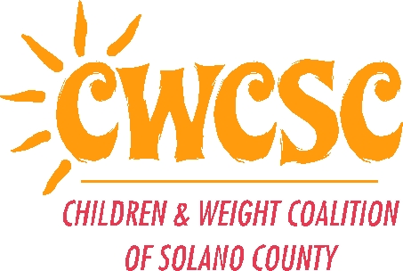
CHILDREN AND WEIGHT COALITION

Of SOLANO COUNTY

POWER UP YOUR LIFE!
COMMUNITY MINI-GRANTS
AWARDS

The Children and Weight Coalition of Solano County is pleased to announce the award of the following agencies:

- Robert Semple Elementary School, Benicia, CA

- Dixon Nutrition Project, Dixon Unified School District, Dixon, CA

- Student Health Services, Vallejo City Unified School District, Vallejo, CA

- Child Start, Inc., Napa, CA

Each grantee was award $1,000.00 for the project outlined in their application.

Awards will be presented at the June 14, 2005 Children and Weight Coalition meeting.

